AAS Industries Pizza API Technical Documentation
Alex Litchfield and Adam Lupfer
AAS Industries

🍕

Architecture Overview:

The application is based on a web interface with individual API functions. Being a RESTful application, you can create, delete, update, and gather information to and from the database through a web interface. The API’s are sorted by the needs of the two types of users: Staff members and Customers. Staff members have more access to the creation/updating/deletion of ingredients, pizzas, and recipes, while the customer API is more for browsing the menu, setting up an order, paying for the order and creating reviews for ordered pizzas.
The API structure of the application follows a hierarchy:
- The routers define the paths for the API and what arguments are to be sent through to the backend as controller methods. Each endpoint has a router function attached to it, usually with a unique endpoint name, like “<object>_create” for instance.
- The controllers are where the business logic of the application is applied. Each endpoint has a controller function that performs the required operations for storing info to or gathering info from the database to return to the web UI.
- The schemas control how data is transferred based on the type of CRUD operation called from the API, in which creation of, updates to, and general structure of objects are defined.
- The models define what the objects will look like in the database and how each field’s data type is defined.

Router example of the “/pizza_create” endpoint: (/FinalProject/api/routers/staff.py)
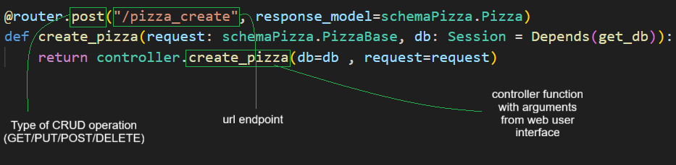

Controller example of the “/pizza_create” endpoint: (/FinalProject/api/controllers/staff.py)
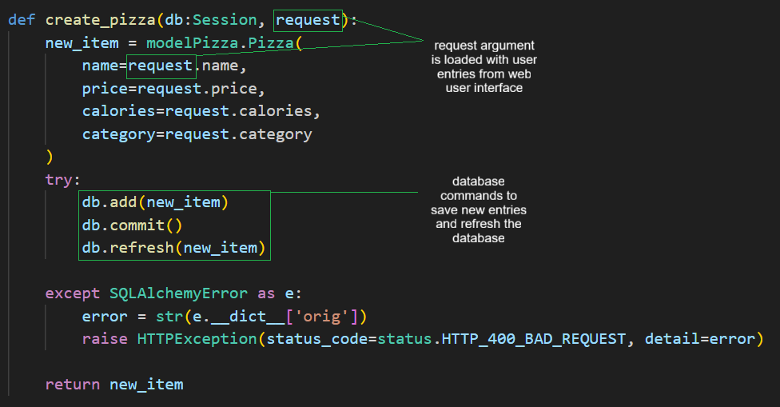

Endpoint Documentation:

Each object in the database generally has an API endpoint for each CRUD operation (GET/PUT/POST/DELETE). These operations are separated based on the user and their allowances (Staff members have access to creating ingredients, pizzas, or seeing revenue, while customers can browse the menu, create and pay for orders, and leave reviews). The following is a table of all of the active endpoints that can be used, sorted by user permissions and followed by their operation:

Customer API (“/customer”)
Endpoint | CRUD Operation | Details
“/pizza” | GET | Gather a list of all the pizzas on the menu.
“/pizza_by_category” | GET | Gather all the pizzas on the menu by a certain category.
“/order/{order_id}/status” | GET | Gather an order’s status.
“/order_create” | POST | Create a new order object.
“/order_detail_create” | POST | Create a new order detail for an order.
“/customer_create” | POST | Create a new customer profile(ID).
“/payment_create” | POST | Create a new payment method.
“/review_create” | POST | Create a new review for a pizza.
“/order/{order_id}” | PUT | Update an order.
“/order_detail/{order_detail_id}” | PUT | Update the details of an order.
“/payment_update” | PUT | Update payment information.
“/pay_for_order” | PUT | Updating an order to be paid in full with.
“/review_update” | PUT | Update the review for a pizza.
“/add_promo_to_order” | PUT | Add a promo code to an active order.
“/order/{order_id}” | DELETE | Delete an order.
“/order_detail/{order_detail_id}” | DELETE | Delete the details of an order.
“/payment/{payment_id}” | DELETE | Delete a payment method.
“/review_delete/{review_id}” | DELETE | Delete a review for a pizza.

Staff API (“/staff”)
Endpoint | CRUD Operation | Details
“/order” | GET | Gather all orders.
“/order_by_status” | GET | Gather all orders with a specific status.
“/order_by_timeframe” | GET | Gather all orders in a specific timeframe.
“/get_details_of_order” | GET | Gather the order_details objects of a specific order.
“/reviews/{customer_id}” | GET | Read the reviews left by customers for a pizza.
“/revenue/{target_date}” | GET | Gathers the total revenue in a single amount generated in a specific day.
“/pizza_create” | POST | Create a new pizza menu item.
“/ingredient_create” | POST | Create a new ingredient for the database.
“/promo_create” | POST | Create a promotional code for discounts.
“/ingredient_usage_create” | POST | Create a required ingredient amount for a specific pizza.
“/ingredient/{item_id}” | PUT | Update the remaining amount of an ingredient.
“/pizza/{pizza_id}” | PUT | Update the calories or category of a pizza menu item.
“/promos/{item_id}” | PUT | Update a promotional code.
“/order/{order_id}/status” | PUT | Update the status of an order.
“/ingredient_usage/{ingredient_usage_id}” | PUT | Update how much of an ingredient is required for a pizza recipe.
“/pizzza/{pizza_id}” | DELETE | Delete a pizza from the menu.
“/ingredient_usage/{ingredient_usage_id}” | DELETE | Delete an ingredient amount required for a pizza recipe.

Development Environment:

- Create a MySQL database schema with the name pizza_api.
- Clone the code repository here using git operations: https://github.com/alitchf2/ITSC-3155-AAS-Industries.git
- Within the codebase in the /ITSC-3155-AAS-Industries/ directory, run the command: ./Scripts/Activate.ps1 (for windows machines) to enter the virtual environment.
- Inside the virtual environment, navigate to the /FinalProject directory and run the command: pip install -r ./requirements.txt
- Inside the /FinalProject directory, navigate to /api/dependencies/config.py and replace the db_password with the password that you set for your MySQL database.
- Once everything is installed properly, back in the /FinalProject directory, run the command: uvicorn api.main:app
- In your web browser, navigate to the url: localhost:8000/docs to see the web user interface.

